Project particles collier

Frank

In this project, I am solving the problem of the size of the particle collider (both linear and circular) that I need if I want to collide two protons and form a higgs boson, in both situations neglecting the relativistic increase of mass of the proton and accounting the relativistic increase of mass of the proton.

I used the equation of kinetic energy,  to calculate the velocity of the proton I need.

The equation , where d is the distance, q*E is the force of an electric field E applied on a particle charged q, t is the time and m is the mass, to calculate the length of the linear collider.

The equation , where FC is the centrifugal force, and , where R is the radius. FL is the lorentz force, and , where B is the magnetic field. We can then derive the equation , where m is the mass, v is the velocity, R is the radius, q is the charge of the particle, and B is the magnetic field to calculate the size of the circular particle(in terms of radius).

There are also some values already known and are necessary in the project:

Mass of the proton=1.6e-27 kg

Charge of a proton=1.6e-19 C

Speed of light=3.0e8 m/s

Also, for all the equations I applied, I have change the unit of every letter to the correct unit.

The purpose of this project is to calculate the size of the liner and the circular particle collider required to reach the velocity of the two protons colliding that would allow them to create the energy enough to create a higg’s boson, the premise is all energy is being converted to kinetic energy. First of all, given that I need 125GeV to create a new higg’s boson, I applied the equation , in this case, there are two protons colliding, so we can derive the equation , and I also have to consider the relativistic increase of mass with the increase of velocity, the mass is also increasing, I define m_rel as the relativistic mass, and , where c is the speed of light. And the equation then changes to , and we apply the value of the mass of the proton and the velocity we assume to achieve 125 GeV, after few trials, I find out the velocity we need is 0.99997117*c.

The next step is to calculate the length of the linear collider we need to achieve such velocity given that the electric field=1000 N/C(a linear collider uses electric field to accelerate particles). We can use the equation  .However, the time is unknown, from the equation , which also means (d is the distance, and distance over time=acceleration), an electric field E would apply a particle with charge q a force F=qE, and we could derive the equation , and then I could calculate the time.

I then insert the value of the charge of the proton, the electric field, the mass of the proton, and the time in the equation , and I get the result that, when the electric field is 1000 N/C, we would need a collider with length 475285.09387631493 m.

With the increase of electric field, the length of the collider needed would decrease, as you can see from this graph.

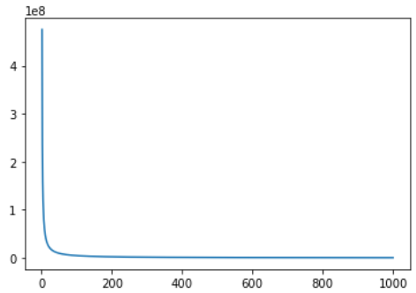

What if we want to make a smaller collider, with length 1000 km? What electric filed would we need? I tried different values in the equation, and get the result that we need the electric field with 475.285 N/C, if we want to make a collider which length is 1000 km.

The second task is to calculate the area of the circular collider (in terms of radius) that we need to reach the velocity to create enough energy for creating a new higgs boson. A circular collider uses magnetic field to accelerate particles, and the force that a magnetic field applies to the particle is called the lorentz force. When a proton is spinning, there is also a centrifugal force acting on it, and if the lorentz force is equal to he centrifugal force, the proton can move forever without colliding to the magnet or escape away, and I have to find the radius to do so.

Given that the magnetic field B=1T, I can apply the derived equation , after I insert the value of v, q and B, I get the result R=3.1686586449374496 m. It’s a pretty small number, however, I didn’t account on the relativistic effect on mass.

I plot the graph that showed how the necessary magnetic field changes as the velocity increases.

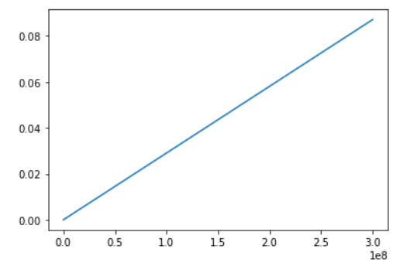

As you can see, the required magnetic field increases as velocity increases.

Now, I am going to account on the relativistic effect on mass, with the equation , and then insert the value again to the equation , and then I get the new radius R=417.29316083149354 m.

However, in actual life, we need more energy to create a higg’s boson, I assume that it’s because not all the energy is transferred to kinetic energy, some of the energy may transfer to heat and light energy as protons are accelerated and collide.

In actual life, we need 13 TeV to create a higg’s boson, I applied the function (accounting on the effect of the relativistic increase of mass), and find out that the radius of a circular collider in real life, given that the magnetic field B=7T, the velocity of the proton needed is 0.999999989335*c.

Then I applied the function  again, and find out that the actual radius needed, when B=7T, is 0.45267856600075445 m.

From the above content, I find out that for a linear collider, we need lots of space and length to construct, but relatively, it is much easier and require much smaller space to build a circular collider.